Day 77

DIY

DIY Questions:

1.How to create a pod have two containers, one nginx, and the other redis?

Solution:

vi multicontainer.yaml

apiVersion: v1

kind: Pod

metadata:

name: multicontainerpod

spec:

containers:

- name: nginxcontainer

image: nginx

- name: rediscontainer

image: redis

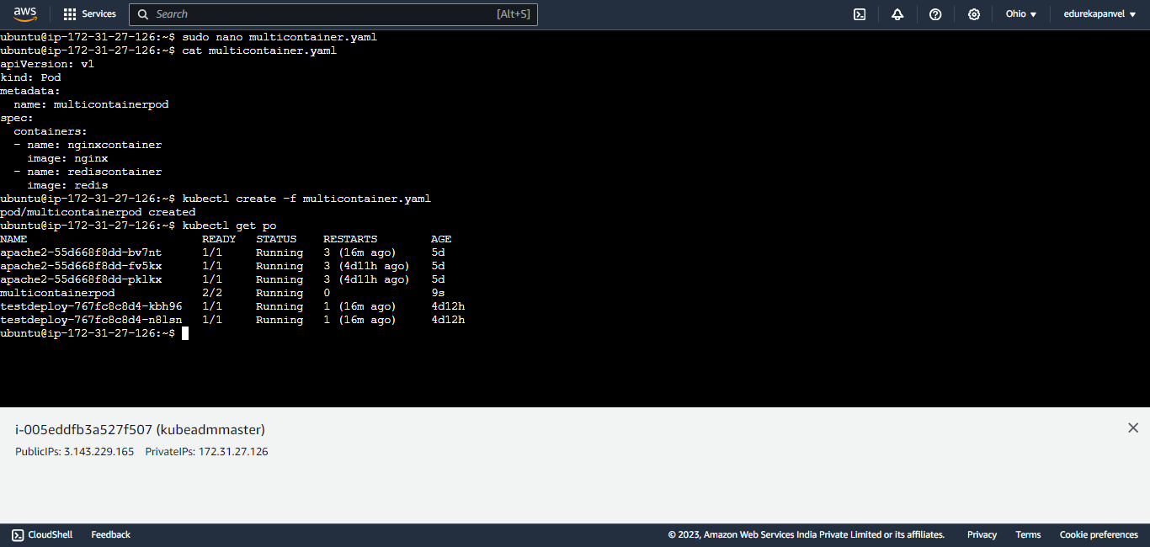

2.Which of the statement is not true about init containers?

a)initcontainers can set up the environment for the main application by installing any pre-requisite

b)if multiple init containers specified then all of them are executed sequentially

c)init container will continue to run after the main application container starts

d)There are no readiness probes used for init containers

solutions:

**c)init container will continue to run after the main application container starts**

3.How to create a Pod with initContainers which will provide a sleep instruction for 60 seconds before the main container (nginx) starts in the same pod?

Solutions:

vi init.yaml

apiVersion: v1

kind: Pod

metadata:

name: initcontainer-ex-1

spec:

initContainers:

- name: sleep-init

image: busybox

command: ["sleep", "60"]

containers:

- name: web

image: nginx

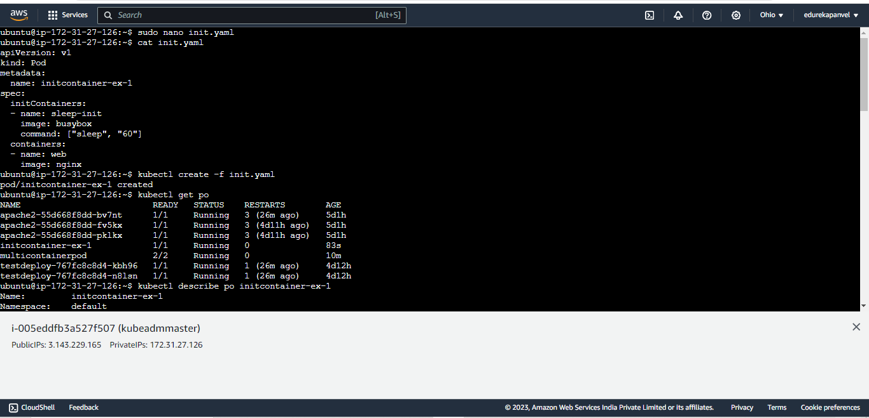

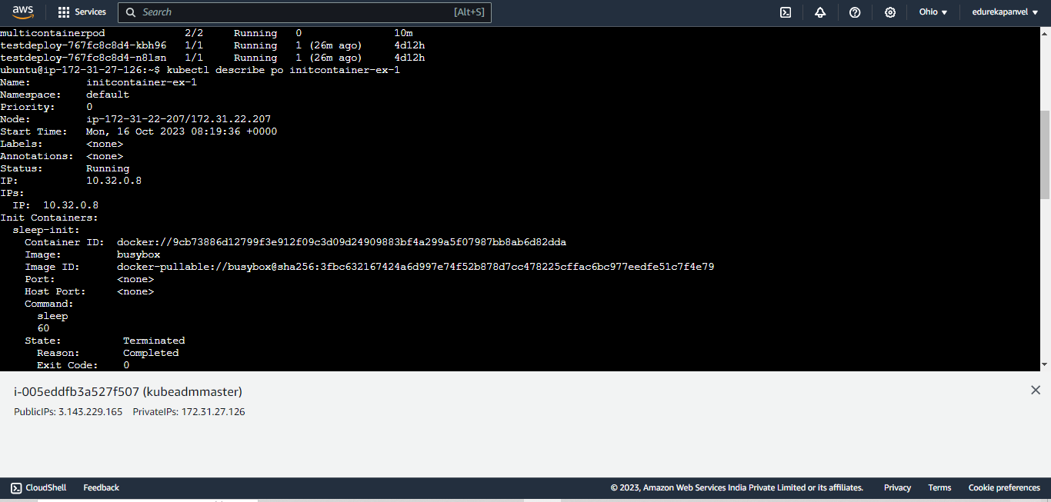

4.Which of the following statement is not true about Kubernetes networking?

a)Every pod has a unique IP address in the cluster

b)Every container in the pod also has a unique IP address

c)The pods connect to the node using a virtual network

d)All the pod's in the cluster are reachable by any other pod over the overlay network

solution:

**b)Every container in the pod also has a unique IP address**

5.Which of the following is not a pod design pattern for multi-container pods in Kubernetes?

a)sidecar pattern

b)adapter pattern

c)ambassador pattern

d)Bridge pattern

solutions:

**d)Bridge pattern**

6.Which of the following is not true about multi-container pods?

a)All containers in multi-container pods have different IP's

b)All containers in multi-container pods can share same volumes

c)Multi-container pods are created when two or more processes want to work as a cohesive/single unit

d)None of the above

solutions:

**a)All containers in multi-container pods have different IP's**